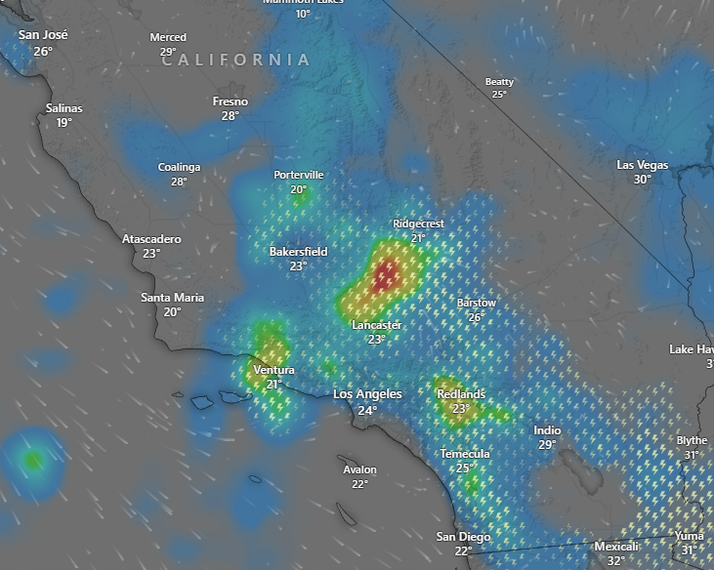
Heavy rain and flash flooding will continue across portions of California, the Southwest, and parts of the Southern Rockies. Remnants of Storm Mario continues to impact California, Southwest, and parts of the Southern Rockies through Friday. Due to rainfall totals possibly reaching 2-4" with rainfall rates at >1-2"hr, some parts of California (mostly central and southern California) under a Slight Risk (level 2/4) for Excessive Rainfall and localized flash
flooding. In addition, several parts of the Southwest has been under a Flood Watch through Friday

Tropical Storm Gabrielle churns in the central Atlantic, the projected track indicates that the storm will not pose any threat to South Carolina or the south eastern U.S. coast. Gabrielle, with sustained winds of 50 mph and gusts up to 65 mph, remains well offshore – about 700 miles east of the northern Lesser Antilles.Thunderstorms have been rapidly developing in the northeast quadrant of the tropical cyclone. That core development is usually the first sign of strengthening, and Gabrielle is following that path. Gabrielle is expected to gradually strengthen over the coming days. By Sunday morning, the storm could reach sustained winds of 65 mph, and by Sunday evening, it's projected to become a Category 1 hurricane with 75 mph winds. By Monday, the storm is forecast to turn northward, potentially intensifying to a Category 2 hurricane with winds near 100 mph as it approaches Bermuda from the southeast – staying roughly 100 to 200 miles offshore. Current models suggest the storm will continue a north eastward track through Tuesday night, heading out into the open North Atlantic.

