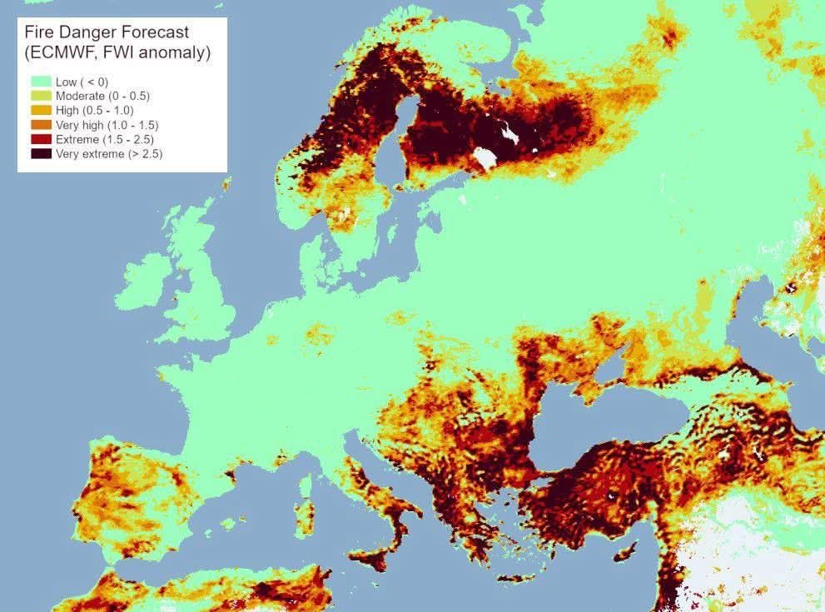
WILDFIRES 🔥 EUROPE
Europe is burning much faster in 2025:
237,153 ha already scorched — nearly double last year
1,250 wildfires in 2025
8.24 Mt CO₂ emitted — a major climate feedback

