Marburg Outbreak in Ethiopia
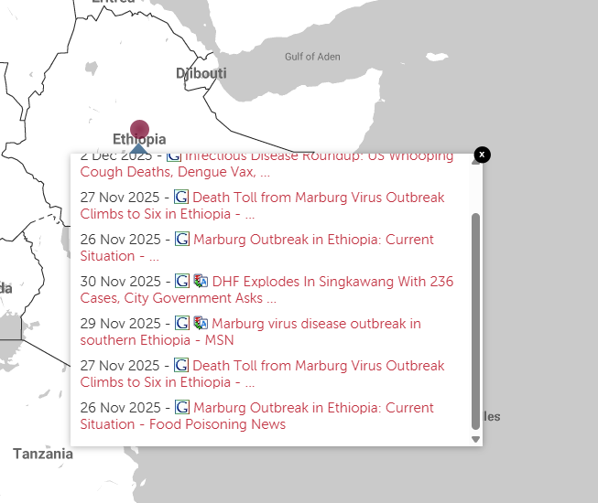
Affected Areas
South Ethiopia and Sidama Region, mainly Jinka, and suspected areas include Hawassa and Sodo cities.
Hazard Types
Virus outbreak
Hazard Summary
Ethiopia’s Ministry of Health has confirmed an outbreak of Marburg virus disease in the South Ethiopia Region, the first of its kind in the country mainly in Jinka Town and surrounding rural kebeles within the South Omo Zone. Marburg is a rare but severe viral hemorrhagic fever, similar to Ebola, that can cause serious illness and death.
Reports indicate that at least 12 confirmed cases, including 7 deaths, and 3 probable cases have occurred.

