Extreme temperatures in Western Australia
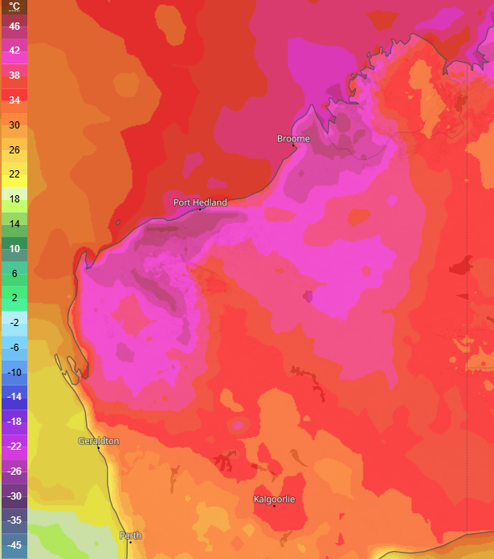
Affected Areas
Port Hedland, Broome, Pilbara region, Northern Interior of Western Australia, Kalgoorlie, Geraldton, Perth and surrounding areas
Hazard Types
Extreme heat and fire risk
Hazard Summary
Western Australia is facing an extreme heatwave, especially around Port Hedland, Broome, and the Pilbara region. The conditions are highly favorable for bushfires, with significant risk in the northern and inland regions. Maximum temperatures are forecast to range from the high thirties to the mid-forties with overnight minimum temperatures in the mid to high twenties. Multiple areas in western Australia and surrounding regions fall under the extreme zone of fire danger.

