Extreme Temperatures in Namibia
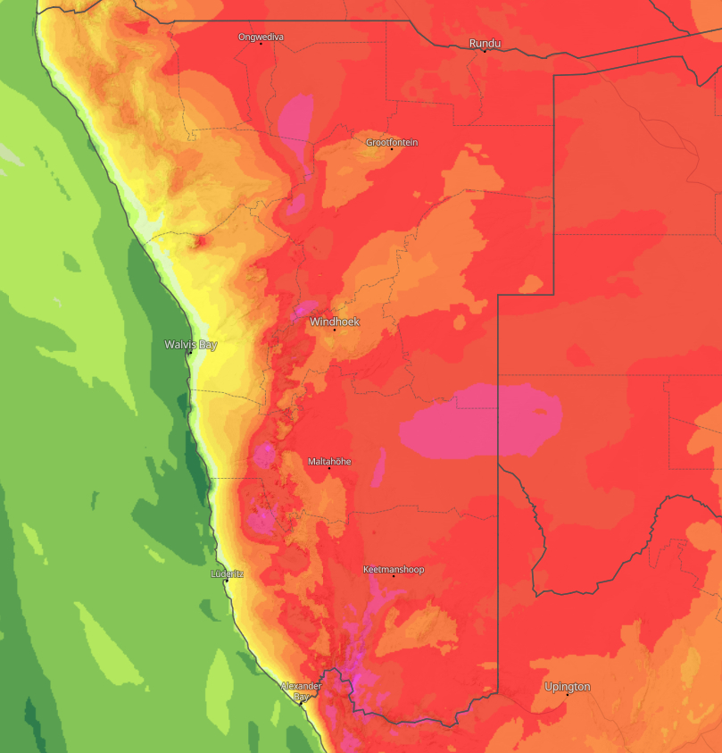
Affected Areas
Central Namibia, Southern Namibia, Northern Namibia, Western Escarpment, Kunene and Hardap regions
Hazard Types
High temperatures/ heatwave
Hazard Summary
The region shown is experiencing a severe heatwave, with widespread high to extreme temperatures across most parts of Namibia and adjoining regions of Botswana and South Africa. The inland desert regions are the most affected, with heat levels potentially high enough to threaten human health, livestock, vegetation, and infrastructure. Moreover, various areas in the Khomas, Hardap and Kunene regions are significantly prone to wildfires that are likely to result in both life and property loss.

