Flooding in Sri Lanka
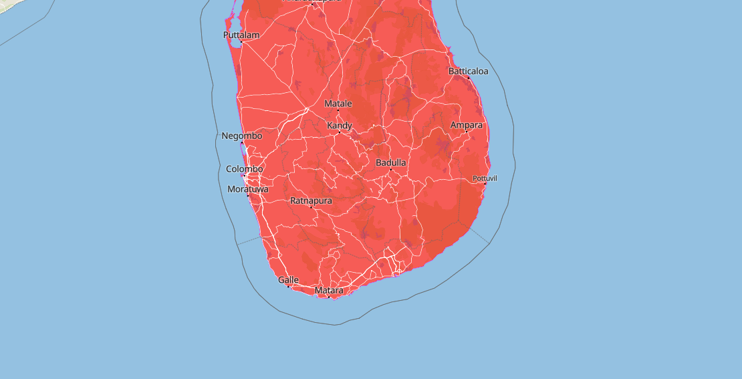
Source: meteoblue

Affected Areas
Most affected areas will be Western Province (Colombo, Gampaha, Kalutara); Sabaragamuwa (Ratnapura, Kegalle); Central Province (Kandy, Matale, Nuwara Eliya); North-Central (Anuradhapura, Polonnaruwa); Eastern (Batticaloa, Ampara); Uva (Badulla); Southern (Galle, Matara)
Hazard Types
Intense Flooding
Hazard Summary
On 28/11/2025, a flood started in Sri Lanka, and still active. The flood caused 355 deaths and 209568 displaced.

