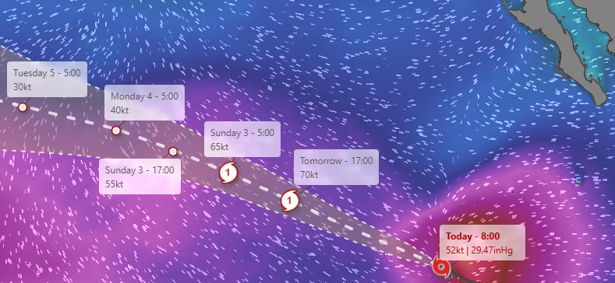
Tropical Storm Gil was strengthening in the eastern Pacific Ocean on Thursday but wasn't expected to threaten land. The storm is forecast to remain over open water and become a hurricane on Friday. It's about 805 miles (1,295 kilometers) southwest of the Baja California peninsula of Mexico. Gil had maximum sustained winds of 50 mph (85 kph) and was moving west-northwest at 13 mph (20 kph) There are no coastal watches or warnings in effect. The storm is expected to keep traveling to the west-northwest in the coming days, as well as speed up as it crosses over the ocean.

